
Guide to Reading at home

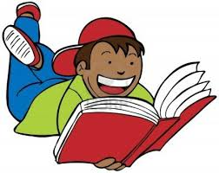

At St Mildred’s Primary Infant School we know how important it is for teachers and parents to work together to give your child the best start. Reading together at home is one of the easiest but most important ways in which you can help your child.
As you share books you are helping improve your child’s reading skills and also showing them how important and enjoyable reading is.
This booklet is a short guide to help you.

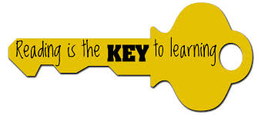

Supporting Reading at Home
- Find a place to sit together that suits you both.
- Try to read for at least 5 to 10 minutes a day and once over the weekend. Encourage it as a pleasurable experience.
- Find some time to talk about the book as well as reading it.
Start with the title, look at the cover and briefly chat about what you might find inside. At the bottom of each page, encourage your child to predict what might happen next. What happened in the story? Does this remind them of anything in their lives or anything they have read before? Did they think the book was funny? Did they spot any interesting words and phrases? Did they enjoy the book?
- Read to your child. You can help your child to understand the emphasis of particular parts of the story.
- Encourage your child to retell the story you have just shared. This will give you an idea of how much they have understood.
- Don’t worry if you feel the book is ‘too easy’ or ‘too hard’. Children need a range of reading materials. Any ‘easy’ book helps them to relax with reading. A difficult book can be read to your child. Both are important.

- If your child misreads a word without changing the meaning, e.g. ‘Dad’ for ‘Father’, you can accept it. If they hesitate, repeat a word or leave one out, don’t worry provided the meaning is not lost. If they say a word which does change the meaning, or they are simply stuck, you can help them by:
- Pointing to the picture if it is relevant
- Ask a question to remind them of the context, e.g. ‘Where did they say they were going?’
- Re-reading the sentence up to the unknown word to remind them of the context
- Saying or pointing to the first letter of the word
- Telling your child the word to avoid losing momentum
- If the word can be read easily by sounding out the letters, encourage them or help them to do this.

Pause, Prompt and Praise
PAUSE to help them work out the new words PROMPT by using some of the techniques mentioned PRAISE them for trying whether they are right or wrong
It is important to use as many clues as possible to help your child when they encounter difficulty.
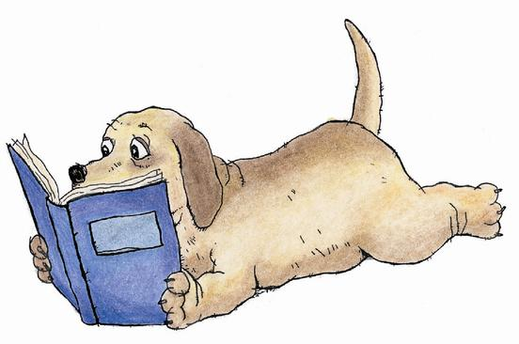

After Reading
Talking about the book with your child at the end will help your child in their enjoyment and understanding of the book.
- Did you enjoy that book? Why? Why not?
- Who was your favourite character? Why?
- Which part did you like the best? Why?
- Was there any part you did not like? Why?
- Would you choose this book/story again?
Which books are best?
- Books your child likes
- Books suggested by your child’s teacher
- Books your child chooses from a library or bookshop that they want to read
- Never be afraid of re-reading books
What else can your child read
Comics Magazines
Travel brochures Instructions or recipes
What’s on television tonight Information books
Manuals Newspapers
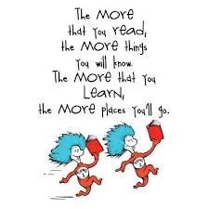Poems Recorded stories
Sports reports Shopping lists

My child is a good reader. Can I still help?
YES! Although children will often want to read in their heads when they become fluent readers there are still many things you can do.
Discuss with them what they have read – about the character, about the plot, about the important parts of the story, about what they have learnt from the information, about their feelings as they read the story … For example:
- Which part of the story did you like best? Why?
- What do you think will happen next?
- Would you like X as a friend? Why?
- What do you think X should have done when..?
- How do you think the story will end?
- Was the information detailed enough?
Encourage them to think about the way the book has been written; the print, the layout and the illustrations.
Discuss any new vocabulary that they came across. Do they know what it means? Can they think of other words with similar meanings?
- Take your child to the library
- Help your child to choose books
- Try reading bits of a book together using different voices!
My child will not read, no matter what I do. How can I help?
- Read to your child as much as possible
- Try not to make an issue out of it
- Talk to your child’s class teacher
- Working together will help
- Praise them when they do read
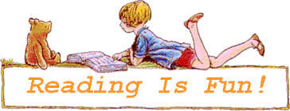

Top Tips to Help with Reading

Read yourself! Set a good example by sharing your reading. Let your children see that you value books and keep them at home.
Keep books safe. Make your child their own special place to keep their books. Show them how to turn pages carefully.
Point out words all around you. Help your child to read the words around them; on food packets in the supermarket, on buses, in newspapers, in recipes.
Visit your library. Its free to join! All libraries have children’s sections. Many also have regular storytelling sessions.
Make time to read. Read a bedtime story with your child every night. Encourage them to share reading with grandparents, brothers and sisters and aunts and uncles.
Be positive! Praise your child for trying hard at their reading. Let them know it’s all right to make mistakes.
Give them time. Let them make a guess before you tell them the word. Let them read to the end of the line before correcting their mistakes. It doesn’t matter if you have to tell them the word sometimes.
Let them read their favourites. Its good practice to read a book again and we all get enjoyment from the books we love the most! Don’t worry if they only read one kind of book. If they are really stuck, ask the librarian or teacher to suggest something else they might like.
Make the story come to life. Encourage your child to read with expression. This will help them read more fluently.
Ask lots of questions about the story. What would you have done if you were ……? Does this book remind you of anything that has happened to you? Can you guess what is going to happen next?
Use a dictionary. Buy a simple dictionary and use it to check the meanings of new words.
Keep in touch with the school. Make sure your child swaps their home reading books regularly at school and try to make a regular time slot of about 10 minutes to hear them read. Remember to sign your reading record book too.
If English is not your family’s first language: You can buy dual language books. You can talk about books and stories in any language.

Some useful websites
http://www.booktrust.org.uk/

http://www.wordsforlife.org.uk/

http://www.bbc.co.uk/schools/parents/primary_support/

http://www.lovereading4kids.co.uk/

http://resources.woodlands-junior.kent.sch.uk/interactive/onlinestory.htm#talk

http://www.myonlinereading.com/

https://readingagency.org.uk/news/blog/why-is-reading-for-pleasure-important.html

